Ordering Supplies - Admin Support

Tuesday, November 17, 2015

12:03 PM

The forms are found at G:\Provider Certification & Compliance\Administrative Support\Supply Orders

<<Office simplified purchase order Form1a 08-18-11 supplies only.dotx>>

Both order forms are templates and final orders should be saved for reference

One form is for general office supplies (everything except really expensive items and printer supplies), one form is strictly for printer supplies for the desktop printers. The really expensive items must go through several layers of management and procurement for approval and are incredibly rare and will not be covered here.

The costs in the catalog are NOT what SDS pays for an item. There are special rates for many items.

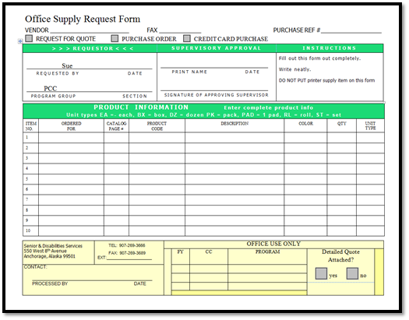

* + Items needed are identified in the catalog and the above form is filled in.
  + It is taken to the Unit manager for approval or revisions and then downstairs to Admin for procurement
  + The items are ordered and come in 3-5 business days (give or take) unless something is back ordered then just the back orders take longer.

<<HP Printer Supplies Request Form.dotx>>

Date Stamper Maintenance - Admin Support

Thursday, October 15, 2015

10:58 AM

**Changing ink**

The date stamper uses a standard ink cartridge located in the supply cabinet. It is a simple matter of lifting the lid, removing the old cartridge and installing the new one exactly the same way the old one came out.

**Sending off site for repair**

About every 3-5 years the date stamping machine will need to be sent to Los Angeles for a full rebuild repair. This costs the state about $500-700 with shipping. Unfortunately despite signs on the original box and custom padding requesting it not be destroyed it was in 2015 after it's last refurbish trip. A new box will need to be found in about 2020 when it will be due once more for repair.

**The date stamper's information is as follows:**

**Model**: DS-6500

**Purchase Year**: July 2010

**Manufacturer**: Shear Tech

**Last Refurbish**: July 2015

**Ink Cartridge**: C6602A

**Change frequency**: 2-3 times per year

<http://www.sheartech.net/ds6500/bates_machine.htm>

Copier - Admin Support

Thursday, October 15, 2015

10:58 AM

**Ordering parts**

To order parts for the Xerox simply email or talk to Admin at the front desk and she can point out which parts are correct for the PCC machine. If parts are running low it is her responsibility to order and keep a stock available. PCC should have at least one full set of toner, drums, rollers and a waste cartridge in the PCC copy room. If one is used up simply notify Admin that you are removing a replacement backup part for the next time it is needed. Parts for the Xerox in PCC seem to be lasting about 3-6 months depending on volume printed.,

**Replacing parts**

Each part for the printer comes with a quick guide for replacement. If there is any problem refer to the guide that came with the part or ask Admin

**General troubleshooting**

Most issues with the Xerox are fairly self explanatory and the screen on the machine will walk the user through resolution. In the event that the screen is not helpful <https://10.2.178.250/index.dhtml> is the remote site for machine management and has tools to tell the user what the error code is and research can be done to determine if there is an easy fix.

If after 3 tries of simple troubleshooting the machine is still not working properly Unit Management and Admin can be contacted to request repair services to come out to look at the machine.

**Starting up and shutting down correctly**

The Xerox machine has a very specific way to shut it off in the event of a necessary reboot.

* Turn off and wait for the machine to completely shut down via the grey button behind the clear door
* Open the main front door on the machine after shut down and shut off the second power switch
* Wait at least 3 minutes for the machine's memory to completely dump
* Turn the front door switch back on and close the large door
* Turn the second switch back on that is behind the clear door
* It will take the machine about 10-15 minutes to completely power on
* The server that the machine is connected to has memory of the print jobs in the queue and thus resending a job is usually not needed.

Other Equipment - Admin Support

Thursday, October 15, 2015

10:59 AM

**Letter Folder**

The letter folder is 8+ years old and has a touchy plugin that is held in place with scotch tape. If the machine refuses to work wiggle the plug until you hear it cycle and it should work.

**To fold letters**

* Letters should be letterhead up facing the user
* Place gently in back slot and the machine will suck it in and spit it out the front slot
* No more than 3 pages should ever go through this machine!
* If it jams there is a hand wheel to assist with clearing the jam as well as a bottom panel that can be removed

**Hole Punches**

There are 3 styles of hole punches in the office

* Standard hole punches do 10-15 pages per punch
* There are 2 heavy punches that can punch 50 pages each punch
* There is one dual electric punch that can be used to punch either 3 hole or 2 hole the limit for this machine is a max of 20-25 pages. If it jams there is also a manual wheel on the right hand side. Simply push it in and turn it away from you until the machine cycles

**DYMO Printers**

There are both single and dual Dymo label makers in the unit. Each one can take any of the labels available but single Dymos must have the rolls changed out for different types. Occasionally the software will need to be updated and for single Dymos be sure to change the settings when you switch label types. The labels are light sensitive and must be kept in the dark until needed.

**Carts**

There are multiple carts that are part of PCC. There is a grey cart used to carry large or heavy objects such as cases of paper or archiving boxes. There is a small silver cart for small filing work and a large silver cart for major file work. Any or all of these carts are available generally for all staff to use or borrow.

**Electric Stapler**

There is only one electric stapler in the unit currently in the SST's office. It is especially useful for large mail outs where there are many pages that need to be stapled together.

**Headsets**

Several individuals in PCC have Plantonics headsets. These are wireless and generally require very little in setup other than a game of "Can you hear me now" to get the initial settings correct. They are rechargeable.

**Desktop Printers**

The small HP printers that some people have take the 950XL and 951 color cartridges. Please keep in mind that the cartridges have an expiration date and the printer will not accept one that is past the due date. When picking up a new cartridge check the dates on the back of the packages and choose the one that will expire first.

**HP2320 Printer**

This is also a deskside printer but takes tonner cartridges. It has the ability to print directly to labels and envelopes easier than the large Xerox copier.

Send as secondary inbox

Tuesday, April 12, 2016

9:53 AM

Open a new message

Options > From

(you can also add BCC if you want too)

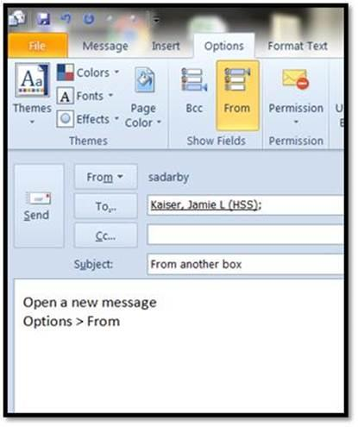

Click the dropdown > Other Email Address

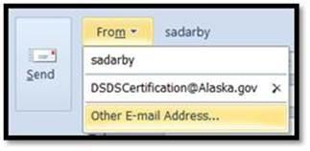

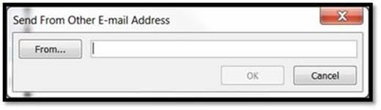

Type off in the search and the Cert box will show on the list

Select and click OK

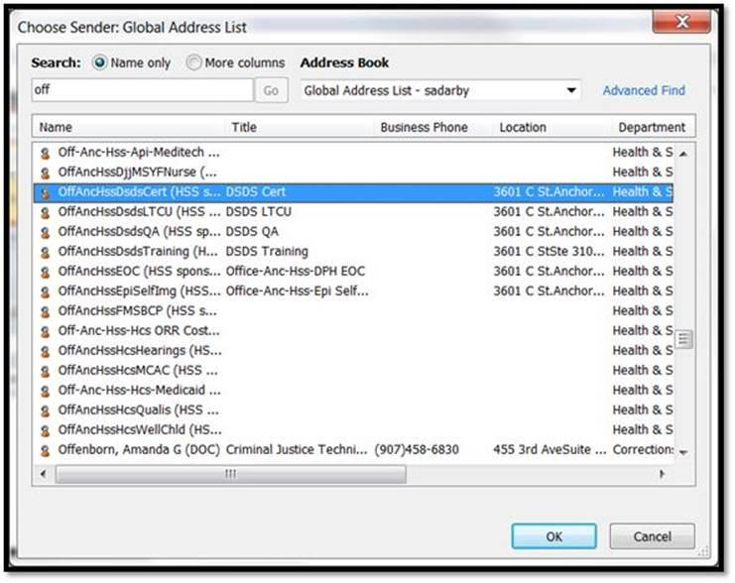

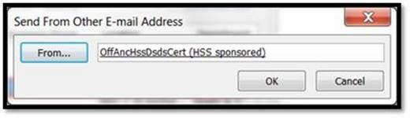

Click OK again and you are ready to send as the Cert Box or the QA or any other box you have permissions for!











Reports that Admin Uses and Applications of them

Wednesday, April 20, 2016

3:01 PM

|  |  |  |  |
| --- | --- | --- | --- |
| Care\_Coordination\_Care\_Coordinator\_Relationships | Y | Y | Agency to Individual relationship shows who works for which agency(ies) |
| Care\_Coordinator\_Care\_Coordination\_Relationship | Y | Y | List of care coordinators and their agencies |
| Group\_Fam\_Home\_HC\_Provider\_Relationship | Y | Y | homes and what agency |
| HC\_Provider\_Group\_Fam\_Home\_Relationship | Y | Y | Agencies and a list of homes including end dates and addresses useful for settings updates |
| Medicaid\_Provider\_Certification\_Application\_and\_Expiration | Y | Y | used for weekly tracking report, first and final notices, tracking what applications are with which worker and if any are missed at recertification and need to be updated or closed, shows open and closed and can show history or future predictions of workload, used for pulling closed files and file cabinet inventories |
| Provider\_Individual\_Services | Y | Y | used to look up one hab or respite type provider at a time to show services and end dates |
| Provider\_Individual\_Services\_All\_Providers | Y | Y | used to show all providers, waivers or services dates and can show compliance |
| Provider\_Search\_Tool | Y | Y | used for care coordination list, pca list and any other short list that might be requested for a specific area or service or a combination of various services based on regions |

Closed Providers - Filing

Thursday, October 15, 2015

11:30 AM

\*\*\*\*\*I propose moving the closed folder out of the Provider Agency Folder due to the limitations of Windows file names. One folder under PCC (which I would like to use as a shorter name for Provider Certification & Compliance too for the same reason) to house Voluntary and Involuntary closures to make finding the folders we need easier during records requests. I would also like to house the closed providers by the year they closed so that the very old folders can be compressed by IT to conserve disk space

1-A CLOSED PROVIDER AGENCY FOLDERS:

* + All closed agency folders shall be placed here after all correspondence and actions have been completed and packet has been scanned and saved, by the SDS staff person handling the closure.

1-A DENIED OR WITHDRAWN APPLICATIONS:

All agency folders where the application was denied or withdrawn shall be placed here, by the staff person handling the action, after all correspondence and scanning of documents are completed.

Documents: All incomplete, denied or withdrawn applications are saved in the root-agency (primary) folder as follows”

Incomplete Applications:

* + Letter saved as “Agency-name(location), App Type, incomplete, date .docx (Acme Agency-Frbks, HCAPP, Incomplete, 02-2012.docx)
  + Application is scanned and saved same as letter above, with .pdf extension

Denied Applications:

* + Letter saved as “Agency-name(Location), App Type, date .docx (Acme Agency-Kodiak, HCD, 02-2012.docx)
  + Application is scanned and saved same as letter above, with .pdf extension

Withdrawn Applications:

* + Letter saved as “Agency-name(Location), App Type, date .docx (Acme Agency-Anc, HCW, 02-2012.docx)
  + Application is scanned and saved same as letter above, with .pdf extension

New CPR & First Aid Course Approval Process - Additional Actions

Friday, October 16, 2015

9:18 AM

**CPR/FA Courses**

It is the duty of the certification staff to approve or deny courses for CPR/FA. There is a list of approved courses on the website. Periodically a provider (and Xerox) will ask if a card from a certain course is acceptable. Review the curriculum and speak to the instructor/institute, school etc. to determine if it is acceptable.

* + Ask for a copy of their curriculum and if there is a mechanism for demonstration of skills.
  + Keep this as a hard copy in the CPR Waiver Binder for future reference ensure there is a date of review on the paperwork.
  + After careful review if the course is acceptable it can be approved
  + Add the provider of the course and the name(s) of the classes to our list of acceptable courses indicating if it meets CPR, First Aid or both
  + Notify Xerox and the provider who asked for the course to be added
  + Post the updated list on the site.
  + No courses that are online exclusively are accepted.

**Unique Cases**

EMT & ETT acceptance started in 2008 and while not on the “official list” management needs to be added as an EMT/ETT & MICP are all certifications issued from the Department of Public Health by the State of Alaska.

Certified Mail - Mail

Thursday, October 15, 2015

10:57 AM

**Reasons to use Certified Mail**

* When decertifying a provider the first notice is done verbally by phone with an email copy of the letter and the official notice is done by certified mail.

**Why the smaller green card is left attached**

* This is left attached to the envelope as it is then taken by the mail person directly to the post office for post marking which is then returned to SDS and made a part of the official record in the event of a Hearing.
* Because the lawyers told QA (before it was PCC) this was how it had to be done legally

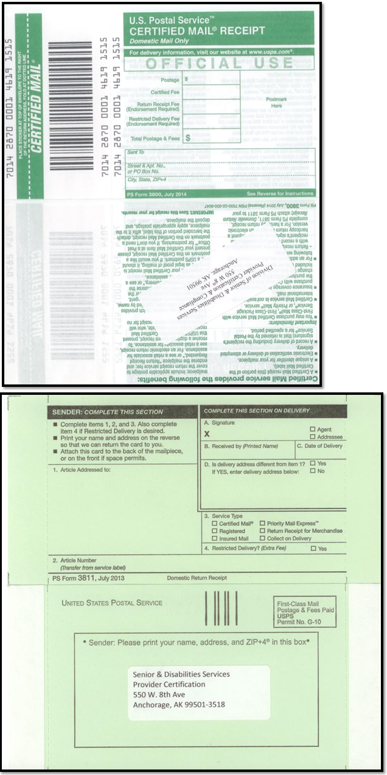

Large Mail Outs - Mail

Thursday, October 15, 2015

10:56 AM

A large mail out can be the result of a QA investigation in which a provider is being shut down or in response to a certification action where the provider is being decertified for other reasons. Either way the following is applicable and required for a successful mail out process.

Notify support staff as early as possible for mail outs over 200 so that additional resources can be procured, borrowed or found if needed!

Generally large mail outs for a decertification action requiring clients to choose a new provider must be done as a Certified Mail letter.

Most if not all mail outs will have to be driven to the Frontier Building by noon for processing as it is impractical to attempt to gather everything for a 9am same day mail out unless it was started the day before.

* + For a mail merge to happen the following fields need to be in the spreadsheet
    - Recipient list in Excel format using reports to pull information Which reports?
    - Name
    - Address hopefully with any c/o or POA etc on separate line/field
    - City, St Zip
    - Waiver the client is on (if waiver related)
    - Cert 1 for the first 4 sets of 4 numbers on a certified form (not part of the report but added later on for merge fields)
    - Cert 2 for the last 4 digits (not part of the report but added later on for merge fields)
    - Care coordinator choice list (if applicable)
    - PCA agency choice list (if applicable)
    - Transfer forms (appropriate to action)
    - Letter
  + Chief of Programs or whomever is signing the letters has the option to have a scanned signature inserted into the letter
  + Management needs to co-locate spreadsheet of data to merge and letter into one network folder to avoid HIPAA violations from emailing information!

This is also a requirement for mail merges in general, where the spreadsheet and letter live is the permanent location, any PDFs made from the labels or letters may move around but the Original Excel and Original Word documents may NOT.

Once all the materials are gathered, merged and printed, stuffing envelopes may be done.

See the [Certified Mail](about:blank) procedure for how to prepare a Certified Mail Out correctly

After the letters are sent be sure to save as a PDF and to split the letters out to individual files as well as notify designated program staff based on the letter's contents so that a copy can go to each client's file. A simple link to where the copies of the letters can be found is sufficient.

Needs revisions Archives Status Guide - Archives

Thursday, October 15, 2015

10:27 AM

Need to find out from Archives what happens when a box meets retention and who decides that it is time for destruction or does it just "go away forever" and we don't need to know when exactly?

Archiving

|  |  |  |  |
| --- | --- | --- | --- |
| Archive Status Category Guide  DS3 vs Record Retention Schedule |  |  |  |
| DS3 Status | Type of Archive status | Retention Schedule | Notes |
| Active | Off site | 1.1 | Offsite storage may include site reviews |
| Inactive – Application Withdrawn | Not archived | N/A | Sent back to provider |
| Inactive – Certified but Enrollment Pending | Not archived | NA/ | Can convert to an NE |
| Inactive – Decertified/ Disenrolled/Terminated | Involuntary | 1.4 | Major Department Action may include site reviews |
| Inactive –Denied Initial Application | Not archived | N/A | Sent back to provider |
| Inactive –Denied Renewal Application | Involuntary | 1.4 | Sent back to provider |
| Inactive –Did Not Reapply, Cert. Expired | Voluntary | 1.2 | Voluntary closure |
| Inactive – Initial Application Pending | Not archived | N/A | Just received may convert to a denial, withdrawn, enrollment pending or active |
| Inactive –Returned Incomplete Application | Not archived | NA/ | Sent back to provider |
| Inactive –Voluntary Closure | Voluntary includes -NE | 1.2 | Provider requests to close may include site reviews |
| Voluntary Closed – Auxiliary | Not a DS3 Status | 1.3 | Includes forgotten items found after main file has been archived |
| Involuntary Closed - Auxillary | Not a DS3 Status | 1.5 | Includes forgotten items found after main file has been archived |

Offsite

Active 1yr on site then 20 off site

Voluntary Closed

1 yr min on site then 7 off site

Involuntary Closed

1yr min on site can be more then 10 off site

Recalling a file

Excels from pre SP

SP

Form

Need to link to the records retention schedule page as well as where a current RTL can be found just in case archives changes the form again

Need to detail the procedure for sorting and converting files from hard file to soft, labels, sorting, data entry and

Waiver Checklist - Incoming Applications

Thursday, October 15, 2015

11:11 AM

<<Matrix sortable of Waiver Initial Cert new Regs 070115.xlsx>>

<<HCB Checklist NEW Regulations Updated -9-10-15 .xlsm>>

* + [**HCB Checklist NEW Regulations Updated -9-10-15 .xlsm**](about:blank) This is a macro driven file but due to State computer settings it cannot be a template so do ***NOT*** hit save. Just print the final list.
  + [**Matrix sortable of Waiver Initial Cert new Regs 070115.xlsx**](about:blank) this is a handy cheat sheet of the requirements for certification that is sortable.

**Note**: Use the initial option as all providers need to have policies reviewed to ensure they meet current requirements.

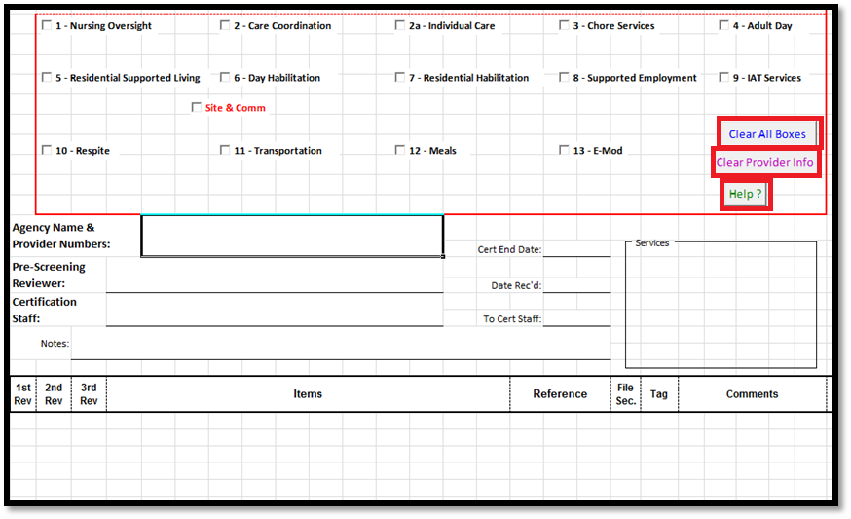

* + **Clear All Boxes** clears the check boxes. This may need to be clicked more than once to ensure all the rows are hidden depending on the services used.
  + Clear Provider Info clears the Agency Name and Dates
  + **Help** is for the person who needs to make modifications to the underlying code that drives this tool
  + Choose a **Service** i.e. Care Coordination
  + Choose **Initial** or **Recert**

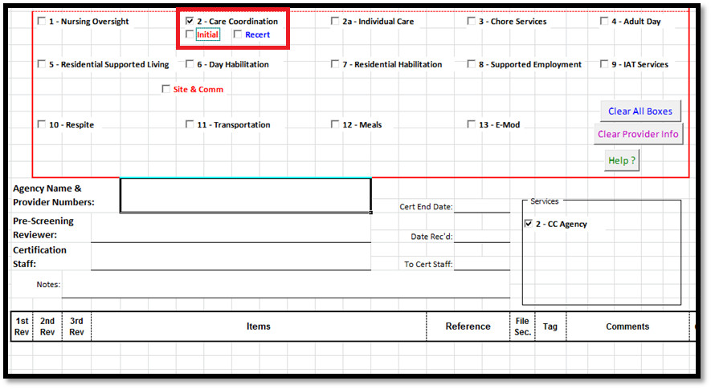

* + Additional options will come up based on the service

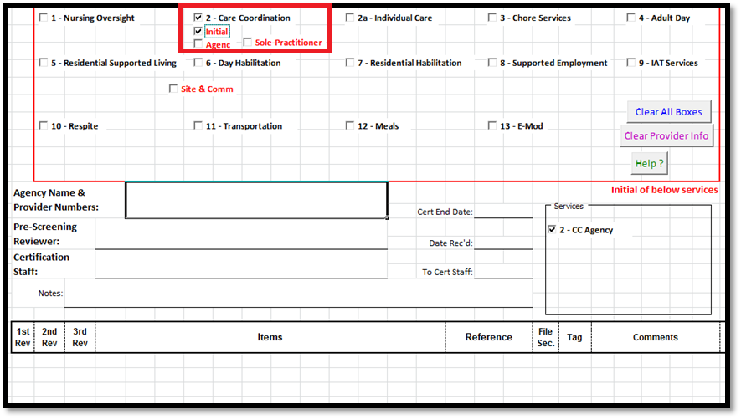

* + As you choose services and other options the items required will appear

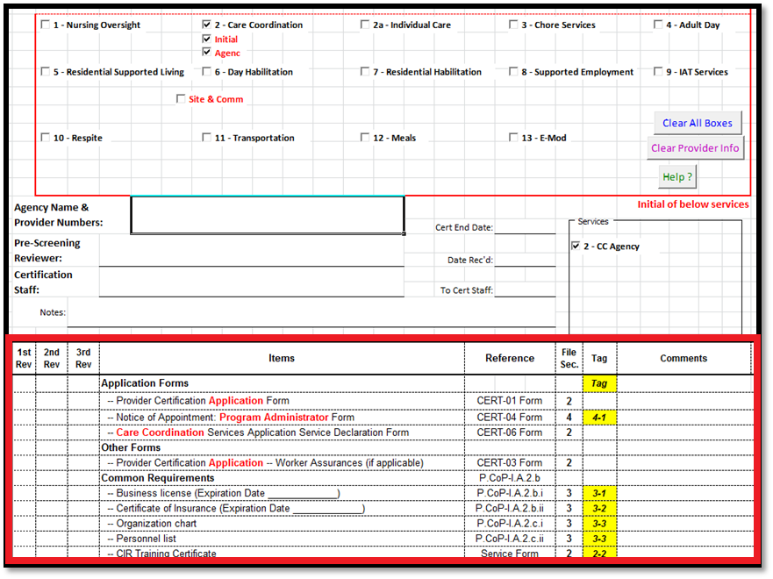

* + Recertification is a similar setup

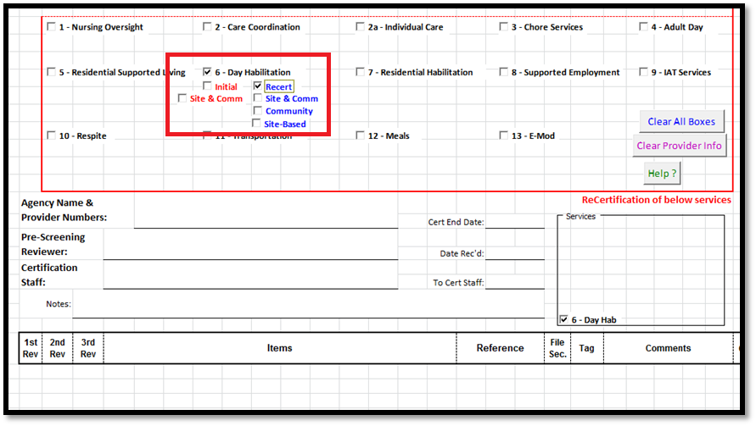

* + After the service(s) are chosen simply enter the needed information
  + **Agency Name** and **Number** (124567 or CMGAPP or HCX etc)

If the agency is large make sure you use provider numbers to aid in matching the correct parts of the application to the right folders!

* + The **End Date** if it applies
  + The **Date Received**
  + **Certification Staff** the application is assigned to
  + The date the application is going **To Cert Staff** member
  + Any **Notes** regarding the provider or application

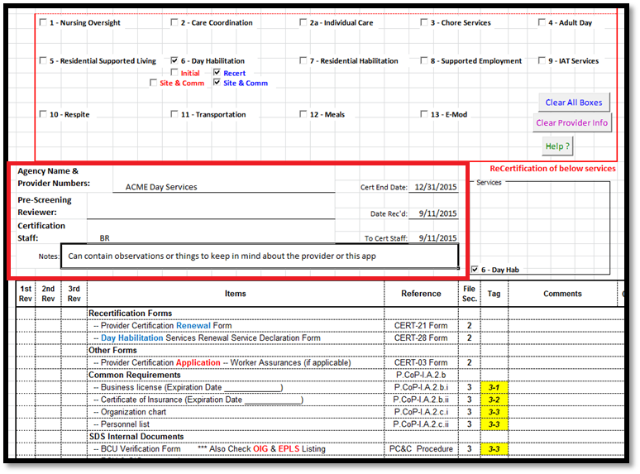

* + **Print** the checklist to include it with the application but **do NOT save**

If you are doing more than one checklist at a time the **Clear All Boxes** will clear the services and the **Clear Provider Info** will reset the Agency info

SharePoint Tracking - Incoming Applications

Thursday, October 15, 2015

9:40 AM

The SharePoint [Application Tracking](https://go.dhss.ak.local/dsds/main/PQA/Lists/Application%20Tracking/AllItems.aspx) Log (<https://go.dhss.ak.local/dsds/main/PQA/Lists/Application%20Tracking/AllItems.aspx>) is found on the [Unit SharePoint Site](https://go.dhss.ak.local/dsds/main/PQA/SitePages/Home.aspx) (<https://go.dhss.ak.local/dsds/main/PQA/SitePages/Home.aspx>)

The [Tracker](https://go.dhss.ak.local/dsds/main/PQA/Lists/Application%20Tracking/AllItems.aspx) is used for Initial Applications, Recertifications and other changes that DS3 does not track such as time lines for processing. The process is the same for adding all application types. The tracker is very wide and can be expanded across both monitors, because of this some of the below diagrams may only show part of the screen or be in multiple pieces.

**View Options**

* + There are two views that can be used for entry of new applications or maintenance of in progress applications
  + **List Tools --> Items** to make the menu appear
  + **New Item** to get to the form for a new entry

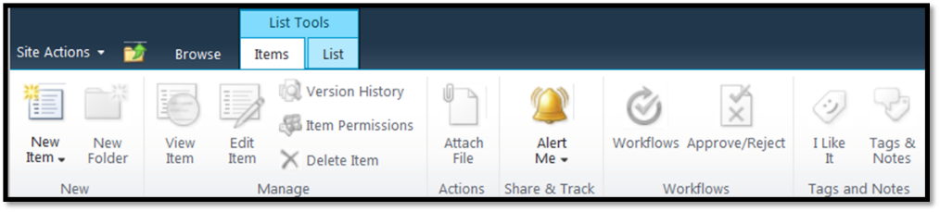

* + Spreadsheet style entry
  + **List Tools -->List--> Datasheet View** which gives a spreadsheet style view
  + From this view simply scroll to the bottom of the list for a new row or you can also edit the cells like a spreadsheet too.

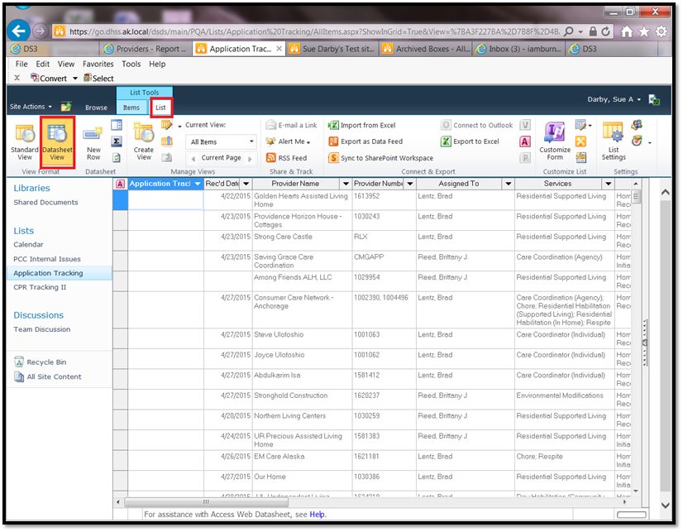

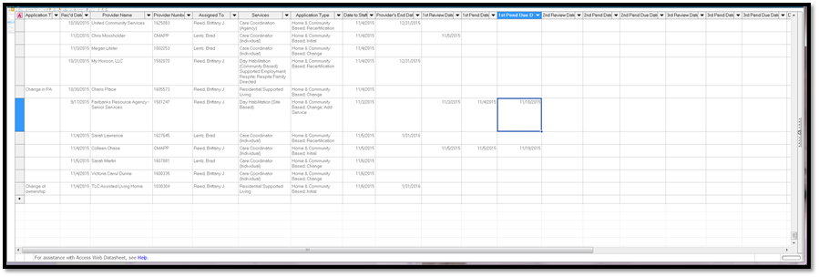

**Adding a New Provider in the Form View**

If you chose the form view:

* + Areas with a \* are required
  + Enter the Provider Name
  + The Provider Number (if it is a recertification) or the CMGAPP, HCAPP etc for an initial
  + Choose Services

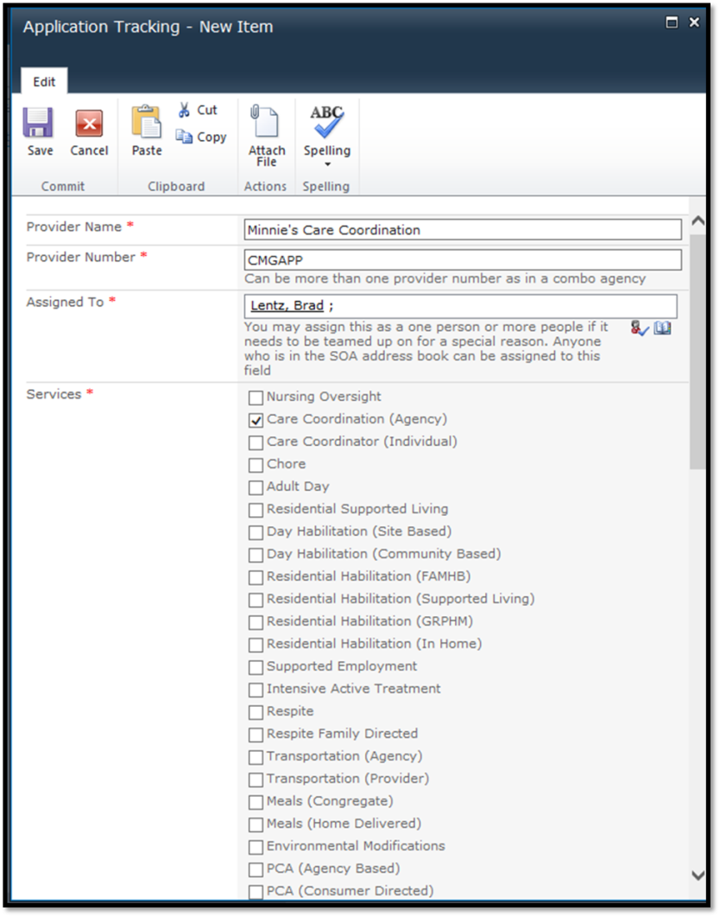

**Assigning to a worker**

* + IF you can spell the name exactly as it would be in the address book (non-case sensitive) you can simply type the name in the box in the main form and press enter. SP will either accept or give an error if you are wrong
  + Click the Open Book icon



* + and search for the person the application will be assigned to

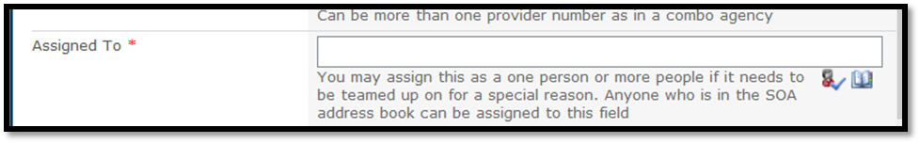

* + Search for the person
  + Add the person by double clicking on the result or clicking the Add Button
  + Click OK

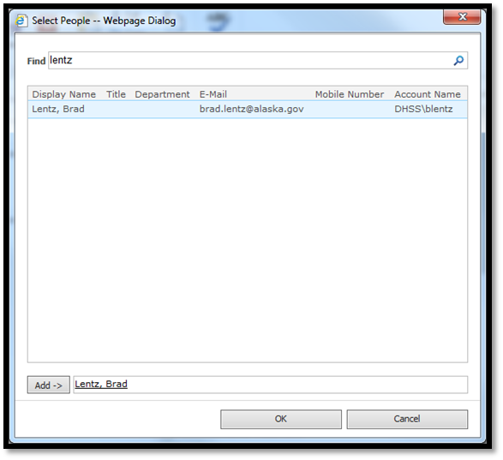

* + Check the appropriate boxes for the services the individual or agency provides
  + Check the boxes for the Application Type

**Dates**

* + Enter the Rec’d Date
  + Enter the Date to Staff
  + Enter the Provider’s End Date if it is a recertification

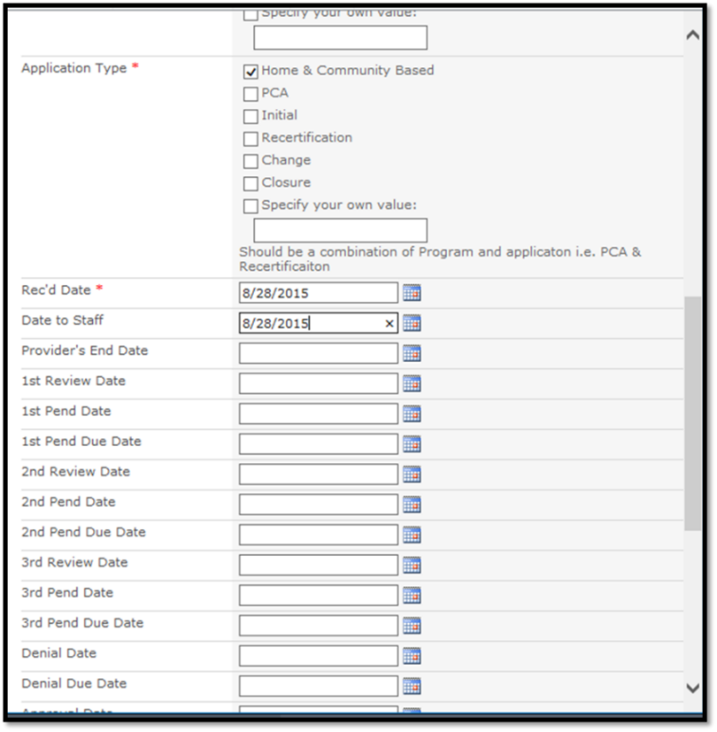

* + Add additional notes regarding the application that might be helpful to the reviewer such as actions going on with other units or a site review
  + If the application is for a new admin or other unique change that does not have a field above use the Application Tracking field otherwise ignore it
  + Add the date the entry is being created (used to track application start to end processing time)

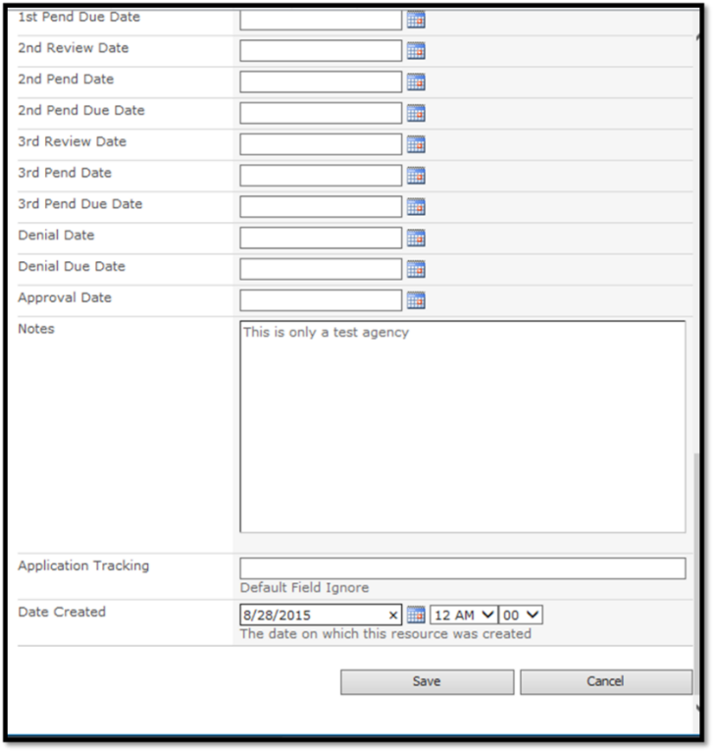

* + Save

**Final Results**

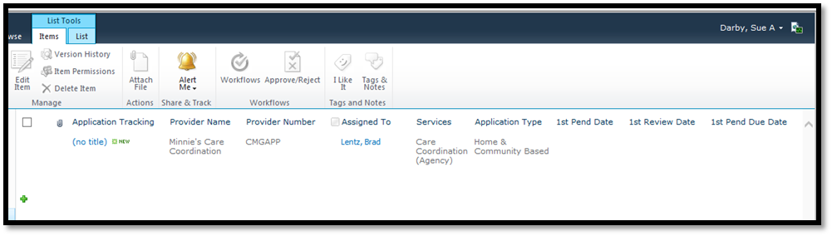

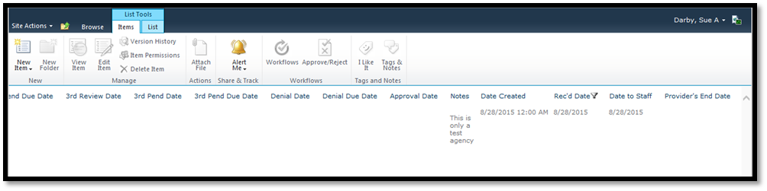

Non-Certified Provider Updates - Application Evaluation

Thursday, October 15, 2015

10:25 AM

**Other Non-Certified Provider Updates**

There are several types of non-certified providers that the PCC unit takes care of. The main reason PCC cares for these providers is that the unit is one of the few in the division that has the ability to fully update or edit the DS3 records for providers, almost everyone else has read only views.

Each of the sections listed has detailed procedures and a little history about the providers. Reports to make the processes a little less time consuming are also mentioned within each process.

Once a year non certified Medical Supply and Long Term Care providers need to be updated. This happens in December or early January at the latest.

* + Pull an Active Provider report
  + Sort to just non-certified providers (no start date and only ending 12/31/XX is a fair hint that they are the right ones but double check as those can also be affiliated Residential Habilitation homes)
  + Look up each active one in Enterprise to determine if they are still active
  + Compare basic contact information with DS3 and update as needed
  + Under Medicaid Codes change the end date to 12/31/xx (the next year)
  + If the provider is no longer active in Enterprise deactivate them in DS3 making the end dates match

DME - Application Evaluation

Thursday, October 15, 2015

11:50 AM

[Durable Medical Equipment (DME)](about:blank) providers are not certified by SDS but are important to the recipient side of SDS as they show up on a [Plan of Care (POC)](about:blank) and therefore should have updated address and phone numbers on the [Details](about:blank) screen along with checking Enterprise for up to date active Medicaid numbers.

There are only a few of these providers and they are only updated yearly generally in December or January at the latest.

There are no notices to send and other than looking them up in DS3 and Enterprise they are not very time consuming. You do however have to make sure that the [COS](about:blank) is also updated to match the provider number on the [Medicaid Codes](about:blank) screen.

**From:** Powers, Jeri L (HSS)

**Sent:** Thursday, December 03, 2015 12:24 PM

**To:** Downey, Carol M (HSS)

**Subject:** RE: Enrollment grid

An SME provider is enrolled as a DME (the newer Enterprise language is Medical Supplier) provider with a specialty of SME No Medicare – see this example:

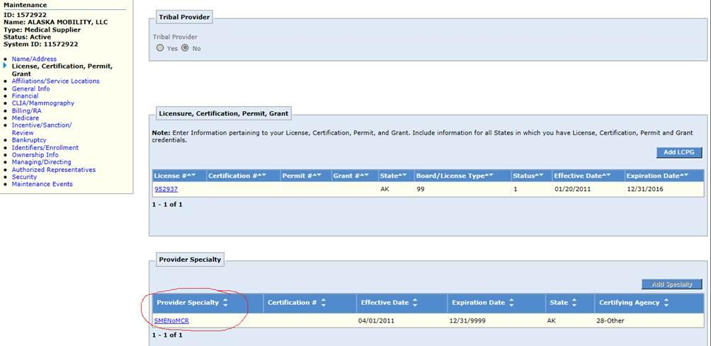

The question about Home Health Agency and Private Duty Nursing Agency is more complicated because there are more steps to determine who can bill for T1002 U2 and T1003 U2.  The Enrollment Grid provides a clue in column P Claim Form Instruction.  A Private Duty Nursing Agency submits claims on a CMS 1500 which requires a renderer (a nurse) while the Home Health Agency submits on a UB04 which does not require a rendering provider.  Otherwise the enrollment requirements are essentially the same.

To pay the claim, Enterprise requires a renderer for codes T1002 U2 and T1003 U2.  Therefore, any agency with provider type 058 can provide specialized PDN if they have a service authorization.

Let me know if something is not clear.

Jeri

**From:** Downey, Carol M (HSS)

**Sent:** Wednesday, December 02, 2015 4:33 PM

**To:** Powers, Jeri L (HSS)

**Subject:** RE: Enrollment grid

Is there anything about how a DME provider (076) is enrolled that shows they are authorized to provide SME services?  I think in the old MMIS there was not but we periodically ran a STARS report to see if they had any recent history of providing SME’s (A9281; E0274 U2; S5160; S5161; V2600; T2028; T2029).

We have a similar question about Home Health agencies (058/060) and whether they are authorized to provide Specialized PDN (PT 058 and providing T1002 U2 or T1003 U2)?

Again, this is looking at how they are enrolled in order to see the specific providers available to be put on an SA for a waiver client with those services.   It would be nice to cut down the list especially for DMEs since there are so many and most never provide an SME.

Thanks for your help Jeri!   Carol

SME - Application Evaluation

Thursday, October 15, 2015

11:50 AM

[Specialized Medical Equipment (SME)](about:blank) providers are not certified by SDS but are important to the recipient side of SDS as they show up on a [Plan of Care (POC)](about:blank) and therefore should have updated address and phone numbers on the [Details](about:blank) screen along with checking Enterprise for up to date active Medicaid numbers.

There are only a few of these providers and they are only updated yearly generally in December or January at the latest.

There are no notices to send and other than looking them up in DS3 and Enterprise they are not very time consuming. You do however have to make sure that the [COS](about:blank) is also updated to match the provider number on the [Medicaid Codes](about:blank) screen.

LTC - Application Evaluation

Thursday, October 15, 2015

11:50 AM

Long Term Care Providers include Hospital Swing Beds and other longer term care facilities that some of our recipients need to transition to when Waiver services can no longer satisfy their needs. This means that PCC must keep a short list of providers that SDS uses, up to date. The main list is found at:

<http://dhss.alaska.gov/dhcs/Documents/hflc/PDF/Health-Facilities-Licensing-and-Cerfication-Facilites-List-2015-06-05.pdf>

There is no report that is currently in use but towards the end of each year these providers should be double checked to see if their Medicaid number is still active in Enterprise and then the end date is updated as is the COS on the [Medicaid Codes](about:blank) page.

Coordinate this effort with the LTC lead in Waivers.

This report could be helpful IF it is updated to reflect the new provider numbers

<https://reports.dhss.alaska.gov/Reports/Pages/Report.aspx?ItemPath=%2fDSDS%2fProviders%2fLTC+Providers>

More reports that could be useful if they are updated

<https://reports.dhss.alaska.gov/Reports/Pages/Folder.aspx?ItemPath=%2fDSDS%2fLong+Term+Care>

Reverse Lookup - DS3 Actions

Thursday, October 15, 2015

9:18 AM

Go to the **Options --> Reverse Lookup**

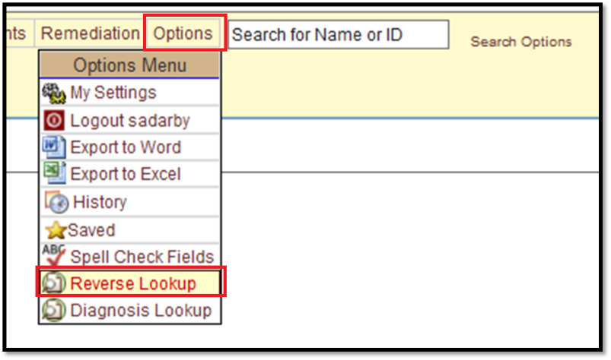

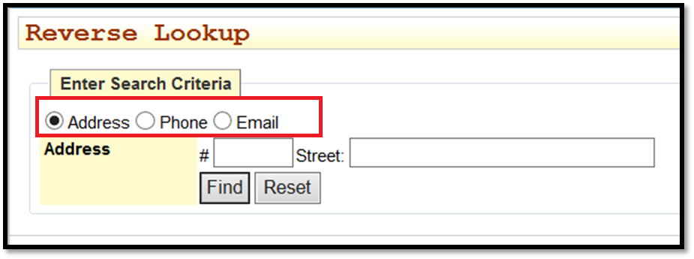

* + Look up the provider by the *Address, Phone* and *Email* provided.
  + If none of the three methods work then go to [add a new provider](about:blank).
  + If you find duplicates or more than one entry you can request a [Record Merge.](about:blank)
  + If you find a record that is a contact such as for an Assisted Living Home or Care Coordinator then you can [Convert the Record](about:blank) but NOT for any *Child Family Habilitation Providers*

New Providers - DS3 Actions

Friday, October 16, 2015

12:27 PM

Within two business days of application receipt, staff inputs provider entity

This is for new **Organizations** (agencies), **Care Coordinators** (individuals)

**Habilitation Homes** that are contracted to an agency (OCS and Assisted Living homes are setup as an Organization)

* + While logged into **DS3**
  + Pull down the **Providers** menu
  + Click on **Create Provider**

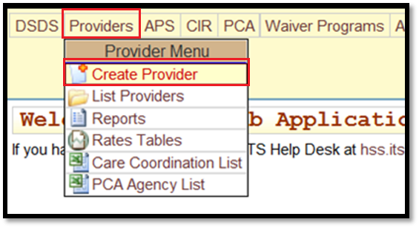

For an **Agency** (Organization) select the **Create as Organization** tab

* + Add the agency **Name**
  + Add the **Region** served
  + Add the **Business License** and **Bus. Lic. Expiration**

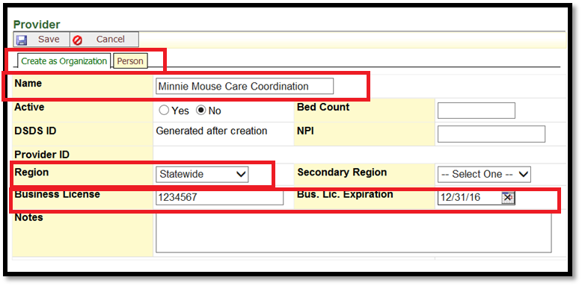

* + Save

**Individual Care Coordinator**

* + Select the **Person Tab**
  + Add the person’s **Name** (Last Name, First Name)
  + Add the **Region** served

**Note**: You do not need to enter *Business License* and *Bus. Lic. Expiration* for an individual.

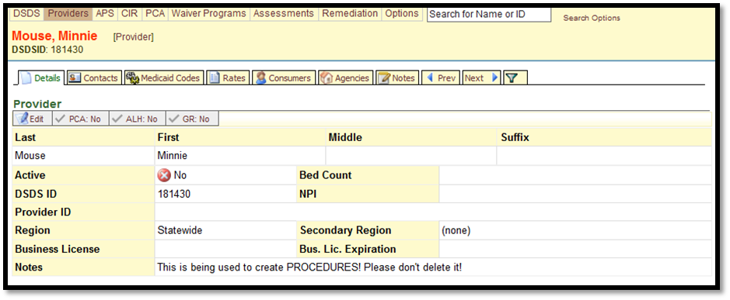

* + Save

New Providers Details Tab - DS3 Actions

Friday, October 16, 2015

12:04 PM

* + Click on the **open** button for each section and for all providers update



* + ***Physical Address***
  + ***Mailing Addresses***
  + ***Phone, Fax and E-Mail*** information.

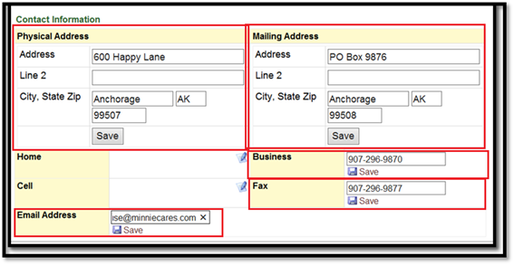

**Hint**: you can have all the boxes open as pictured above and then hit save for each once they are all filled in. Using tab between fields speeds up the entry process.

Be sure that all demographic information(addresses, phone numbers, e-mails) are entered and correct.

Incoming Applications Medicaid Codes Tab - DS3 Actions

Friday, October 16, 2015

12:04 PM

In the first box, type one of the following, repeat if the provider has applied for more than one type of service i.e. RSL and Respite would get RLAPP and HCAPP as 2 entries.

* + CMAPP (care coordinator)
  + CMGAPP (care coordination agency)
  + HCAPP (all HCB services except assisted living and some e-mods that are ONLY EM providers)
  + RLAPP (Residential Supported Living)
  + PCGAPP (PCS Agencies)
  + EMAPP (E-mod providers) Construction companies that only provide this service get an EM

**Note** EMods that are part of a larger HC agency such as Access Alaska have the COS under their HC and do NOT have a separate EM number

* + For larger agencies you may have combinations of HC & RL etc based on what is allowed by regulations. These will have separate Medicaid Code entries.
  + Do not enter any dates.
  + Change the Status to **Inactive – Initial Application Pending**
  + Click the **Add** button.

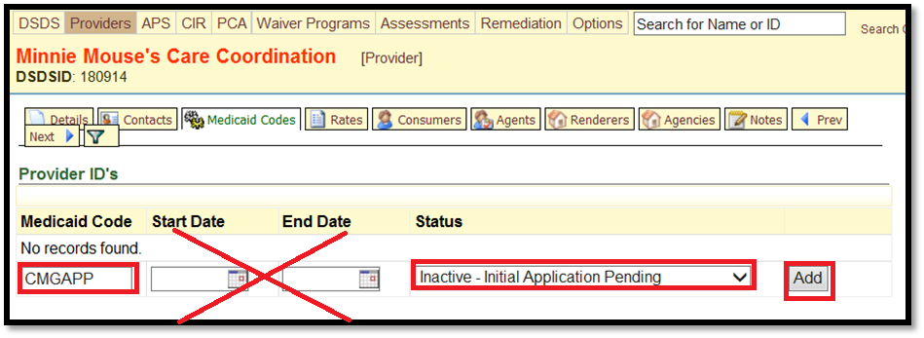

Record Merges - DS3 Actions

Monday, November 23, 2015

10:55 AM

If you do find duplicates the records can and should be merged

* + Search by name

![Machine generated alternative text: 000$ Poeadeos API  PCA *90,0 Poowoo Aae.oorn.oe Reowason Comon 1 encaro sn - Results ___________ 9an Rescue 010W 170019 Ceona H0$fl Ready Care (RosCare) 05040 070477 CcoSaol Koch-ResCare-1013/2013, Dono. Mgel ie Aortitse RN 6*2014 050W 072500 Coind P’o*cS Mqd LeidnOoo,. 904 FRA 903 boor *45 - FuIra, 00(95701 Reedy Care (RosCare) - McI 0105030952 t°o’0.l cuotto (lo w(po2e2eoJp00602sJpa30002)pCoe300(pCoe3oq p4c0370( t,9oase tRAnse 272340 (opraton ene 12031110 Pee.. ledoorage u.g 1400 W Penser Bed. 0200, Andernge, Sic 09503 Phosa 5400 W Benson 9040200. lndoooage. SEc 99503 o’ aeon Ooe04rnd oro ano, corn Opoer enorncewseoaredrn aune cono Ce’., nebnmes n,00oflrn<ao coon Cero, a.oraeoroscar. con 0$., )005.ca n.10.4d..d oh ansie con Ceo.- jnssocanenlonrnscarn con Ponoay Dnn4oescare coon PCA nl001nco nsbonncarn coso. 0$ai (007)2543490 Boniest (007)2543490 Fa (907)222-4070 Ready Care (ResCue) - FuSait 050W 30703 P’044.l )l)025075(1325205((1004405( °C5930jC55C577(CG430C(CC43O0flQ430795( )lan (toesa 272340 OopraOo. 0*00 12031110 Bepie b*.noo unie 3407*00o10545, Fierons. 11(90700 ProsEes 34070apo4*or. Fierons. liC 90700 PCA etab010 001asooooscar. coon Opto, onion OoeØ04odi5 abono coon Olio, nroso’ca tnaorreica, corot Orna’ noornco nnØ&odoo anna coon Oeoor otaboeo 000as000atadIOi sesne corn Giton asooleorescas eat 0$.i »oosca nnto4rncaoo coon Pnrnay otsb000 boeanoqreocaoe COOfl 11004e (907) 970-2550 Besowot (907)4544524 Fan (907)054 0624 Ce..- (007)452-9905 Ready Care (ResCue) - Hosoier 050W 30540 Fooano) (Cuc530 502925 10040344(3’2’27n#)o54510’c0450a3pscaAsa) joao, Ltit 272345 fejeatonbnee 17)110 Beon s— Pi5saes 332 6 Penoso 4e  2. Hoonoo, 4000003 10ni 332 E Plonoe 4e Sss 2, Horneo, 4009003 0$r Soon w.40sd11 auno corn Cero, entones neeoncaro corn Ceo.’ ema nawenoede ante coon Cero, 410a)0000000cVt Cam Doe orna ¡oanande ano. coon Proowy a040100froscare coon 110540 (507)0742304 Fa (507)235-7004 Boneess (507235-70$3 Ready Care (ResCue) - Wasaa 050W 30071 ?10o0401 (1005I4(1002505((l02022 IoCs7s(4Coo3aq(OA-3oo713pCoeoo( ç9AOm License 272340 0,9*0000 Ooee 12031110 Repon Sarna](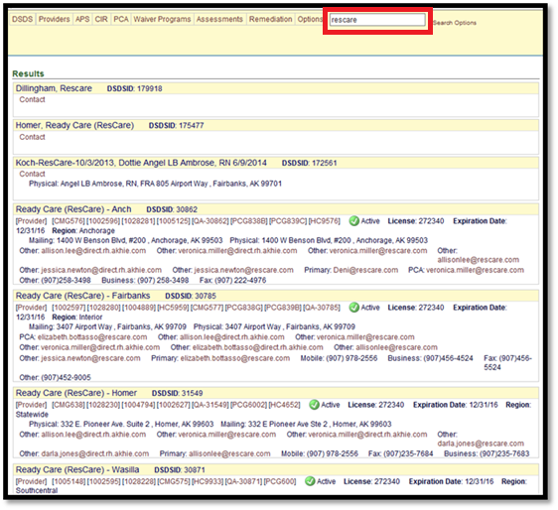)

* + Identify your duplicates or incorrect records

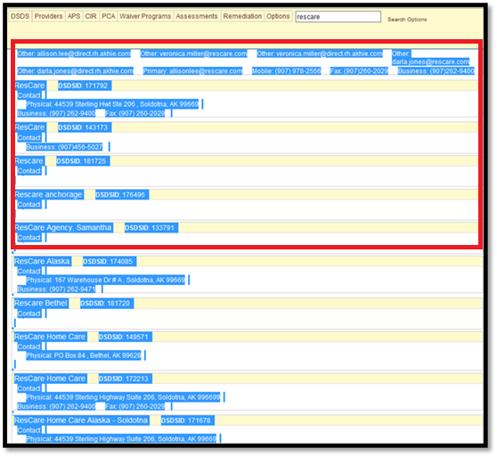

* + Highlight and copy the relevant records from the results list

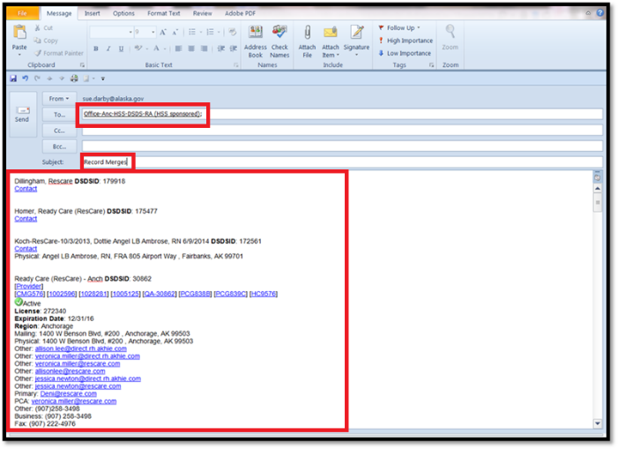

* + Paste the results into a new email to [DSDSResearchAnalysis@alaska.gov](mailto:DSDSResearchAnalysis@alaska.gov)

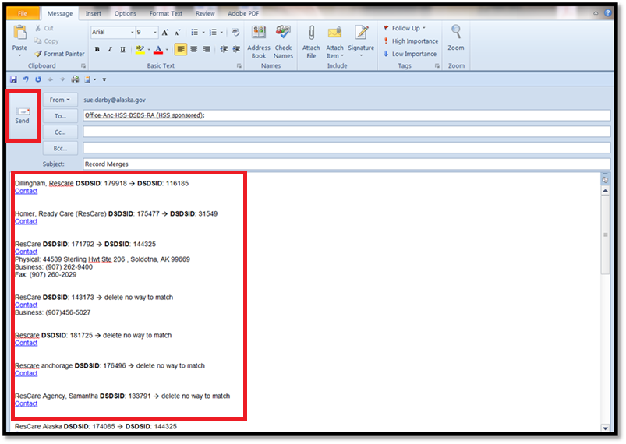

* + Indicate which record the duplicate entry should merge into by DSDSID
  + Identify which record should be kept as best as you can. This is usually an active provider record with one or more contact records that just need to merge. Rarely are there ones that should be plainly deleted but if there is no way to match records then indicate that.
  + If there are questions RAU never hesitates to ask for more information

Recalling a File - Archives

Thursday, October 15, 2015

12:11 PM

There are a number of reasons to recall a file from archives and there are two main systems for finding files that have gone to archives or off site storage. The oldest location is a series of Excel spreadsheets that were used before the SharePoint Archiving site was created in 2010. The information in the Excel files are NOT in the SharePoint due to importing limitations and therefore they have to be manually searched. They are located in the [G:\file plan](about:blank) folder. It is incredibly rare that these files have to be searched for information. The barcodes and box number system in these files is exactly the same and the recall process on the form sent to Admin below will be the same.

* + Receive a request for a file from management

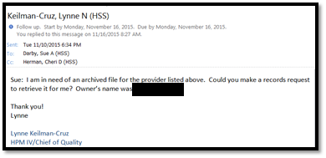

* + Research the correct provider numbers as some files are under an older file system that was alpha-numeric versus the 2013 and later numeric only system and the files are in the SharePoint BOTH ways. Having all the numbers ensures you get all the needed files.

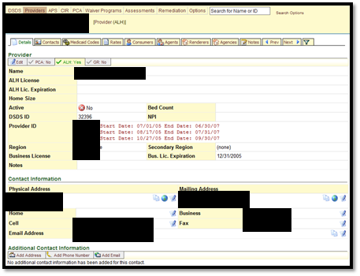

* + Go to the [Archiving SharePoint](https://go.dhss.ak.local/dsds/archive/SitePages/Home.aspx) and download the form on the home page for requesting files.

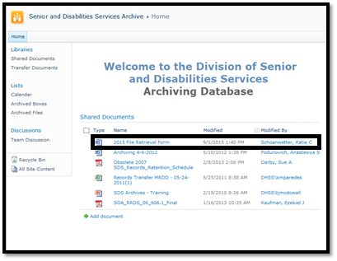

* + Go to the **Archived Files** section

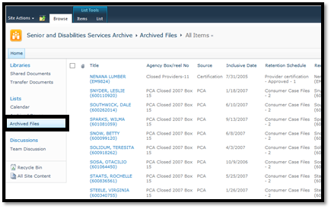

Sort by either Sue Darby (or in the future whomever is doing the Archiving and has sent the box off site)

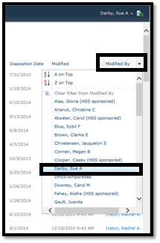

* + Search by the provider's name, numbers and even previous provider names if the agency or person has had a change like this. (DS3 Notes provide old and new names and such changes)

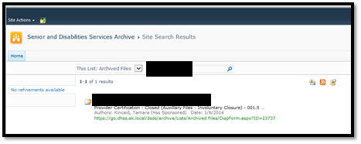

* + There will be a list of results, click the first link to go to the results to see if it is the file you are looking for.

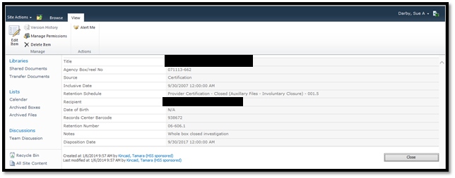

* + The important information on the results screen are the Provider Name, Bar Code and Box Number. On many records there are also additional notes if the file or a whole box relates to something specific like an investigation or it was a very large provider that closed.

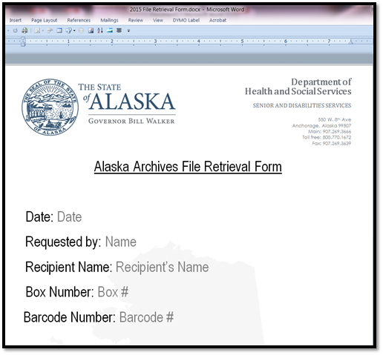

* + Fill out the form above with information from the results in the SharePoint regarding the file(s) or boxes you need. (Recipient Name is the Provider Name on this form)

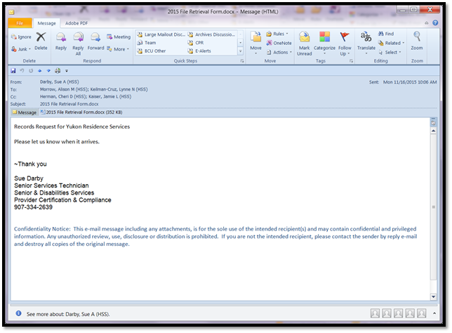

* + Attach the form to an email to Allison (front desk) and any other individuals who need to know it was requested in management

Weekly Reports - Provider Status Report - Reports

Thursday, October 15, 2015

10:29 AM

The *Medicaid Provider Certification Application* report is a very versatile report and is used for not only this *Provider Status* report weekly it is frequently used to track many other things with regard to addresses, status and end dates. It is also used for mail merging first and second notices any if needed any other bulk notices that may have to be sent to providers. It is part of the group of reports used to create a list for File Inventory as well as several other things for the Ad Hoc and Quarterly Reports.

* To pull this report go to the **Report Manager** under **Providers-->Medicaid\_Provider\_Certification\_Application**

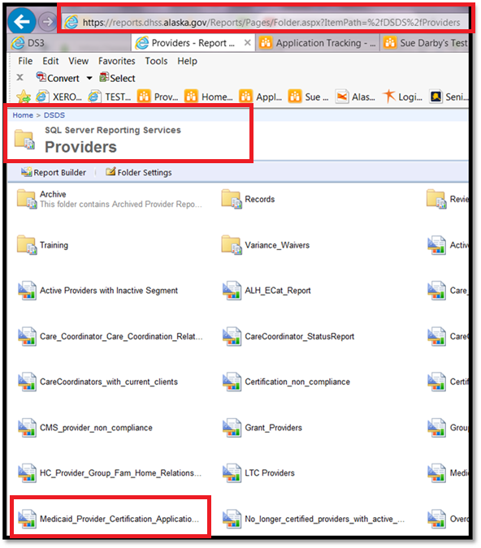

* Choose a **start** and **end date**. This can be the current month or it can be a date in the past or future which can be helpful for closed files or projecting future case loads
* Choose the **Certification Status**
* While this report does say *OR* the reality of the report is that it is actually *AND* so all fields have to be filled in for the report to run.

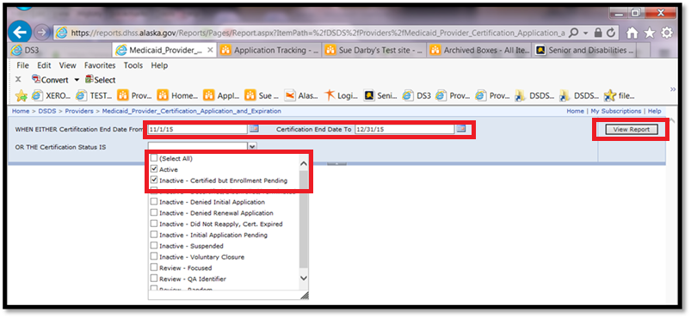

* Once the report appears you will want to **Export** it to **Excel** for further analysis

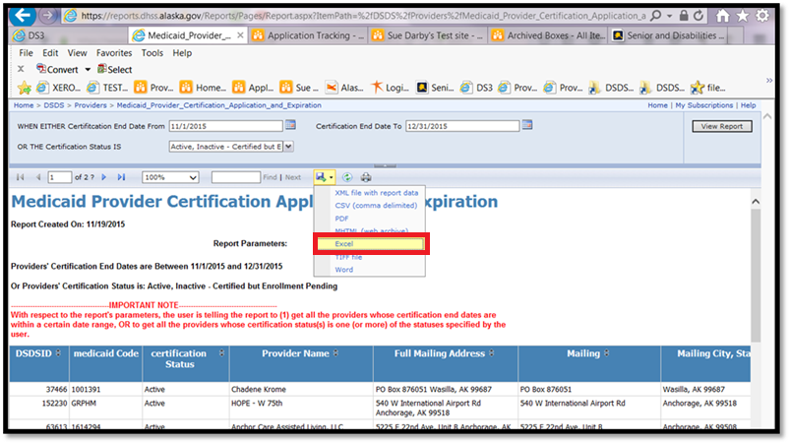

* **Open** the **Spreadsheet** (you will save it later)

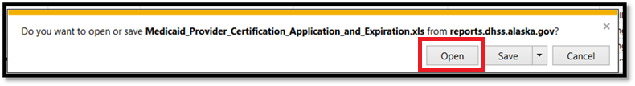

* **Enable Editing** in the **Excel** spreadsheet

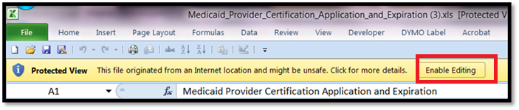

* Highlight rows 1-12 and delete as they are unnecessary to most uses of the report

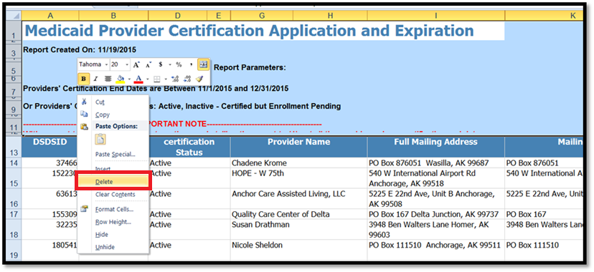

* Highlight, right click and Delete

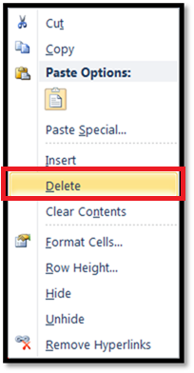

* For the remaining rows hold CTRL and use the and the to highlight the columns and rows

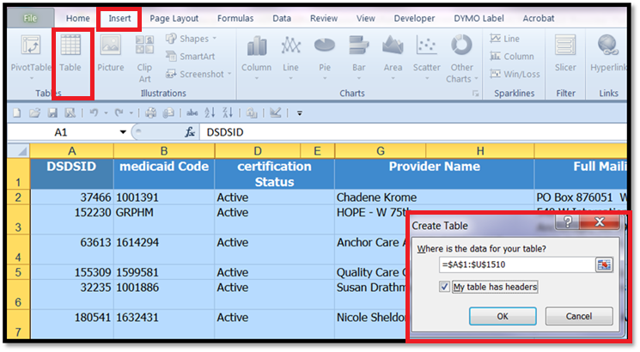

* Go to **Insert Table**
* Be sure to click the box next to **My table has headers**

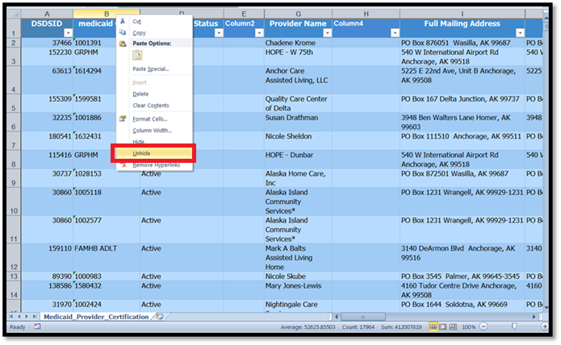

* While everything is still highlighted *right click* a **Heading Row Letter** (A, B, C etc.) and **Unhide** the columns

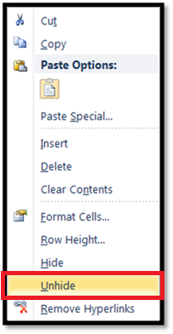

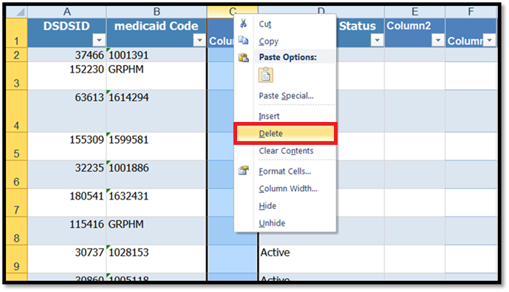

* Click the individual empty columns and delete the extras as they are not needed

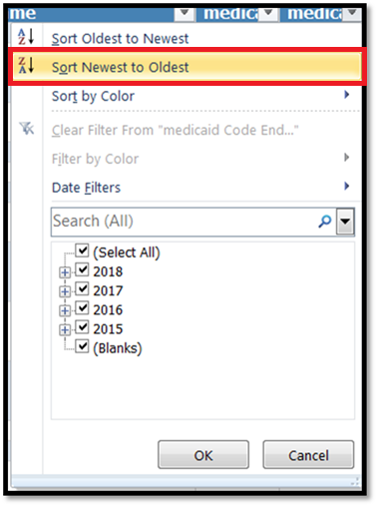

* Using the **Medicaid End Date** column sort the **Newest to Oldest** and **Delete** the rows you do not need

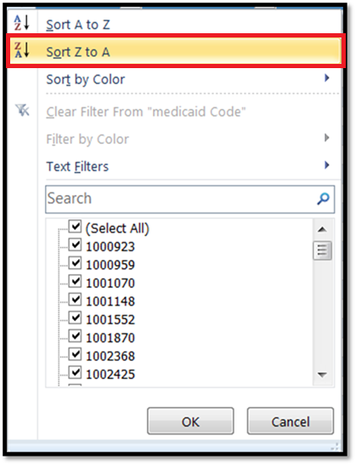

* Using the **Medicaid Code** column sort **Z-A** to get rid of any Hab Homes and future **Inactive - Enrollment Pending** rows

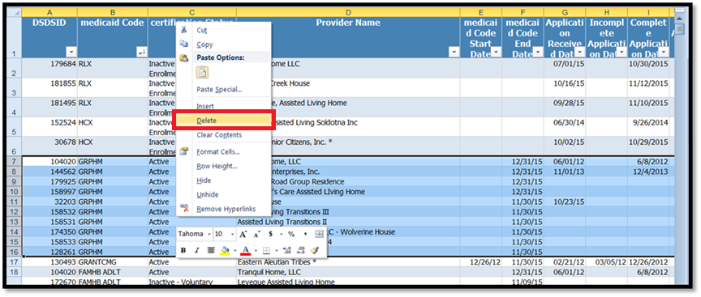

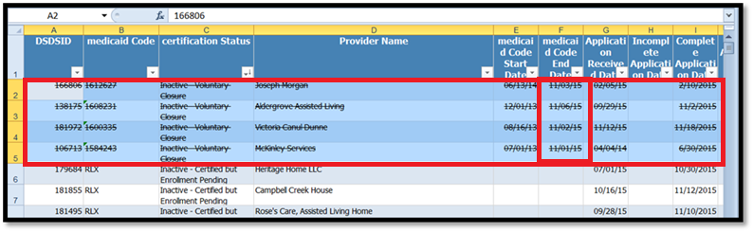

* Use a simple **Strikethrough** for any **Voluntary Closures** that may be important to the month you are looking at

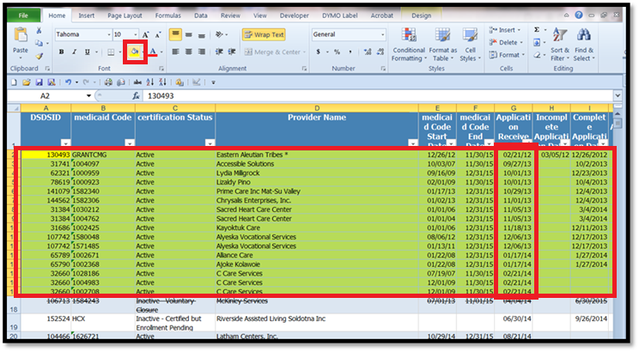

* Sort again **Oldest to Newest** using the **Application Received Date**
* Highlight in **Yellow** the providers that have *old dates* or *no date* to show that they have not arrived

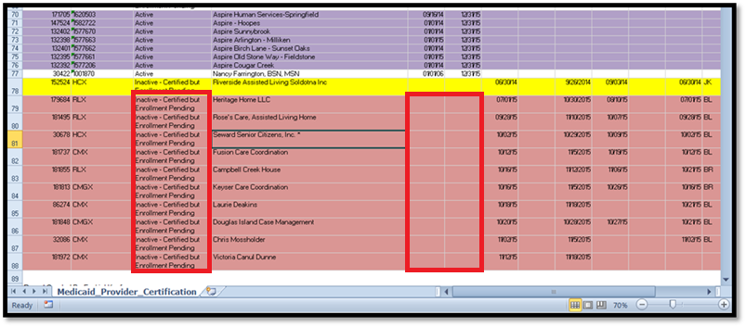

* Look carefully at the **Inactive - Certified Enrollment Pending** providers to see if any *should* be on the report
* Take a look at the dates for the **Denials** column and turn the text only **red** for any ongoing denials

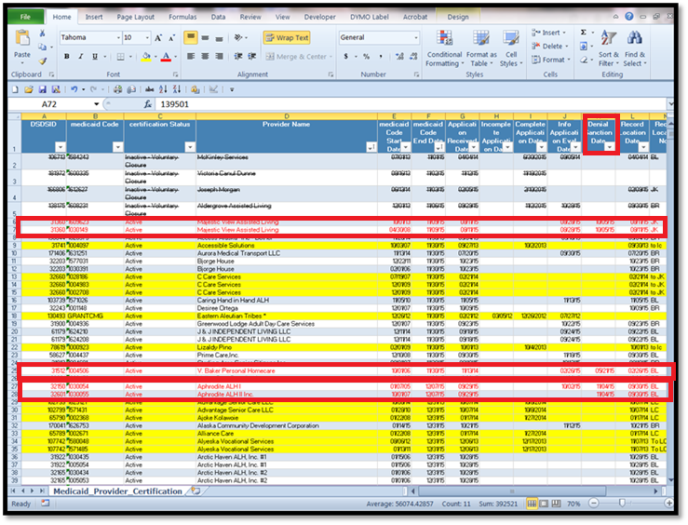

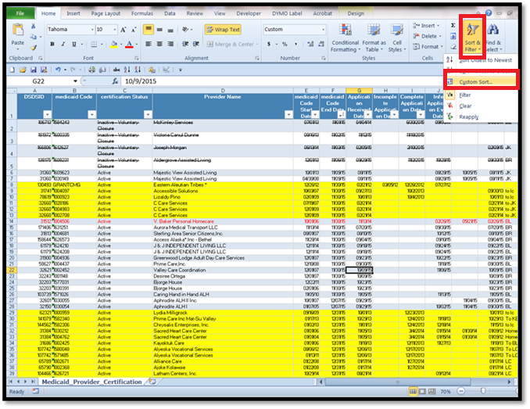

* On the **Home** tab go to the **Sort & Filter** tool and do a **Custom Sort**

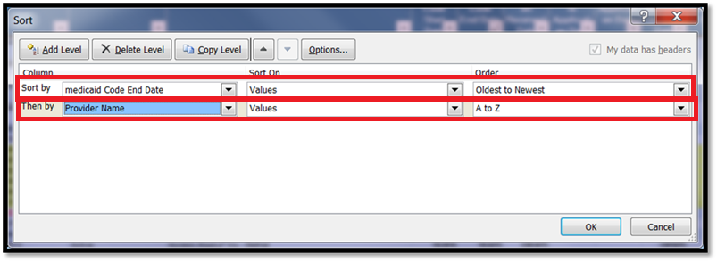

* Sort by **Medicaid Code End Date**, *Oldest to Newest* then by **Provider Name**, *A-Z*

![Machine generated alternative text: Microsoft Excel Favontex S Desktop le Downloads Recent Places Librafles 4 Documents 4 Pibisic .3 Pictures I Videos b Computer g. Local Disk (C) • DVD RW Drive (D s DSDSJhared C» s SADaity (låhasds. s databases (\hssd &j Medicad Provider Cert’ftcationAppficabon.jnd Expêabon 11-19-l5Sx kj pite&ca oeçCemficasionApplicat.onanExpiration l1-5-15.xlsx kj Medicaid_Provider_Certification_Application_and_Expiration 10-28-lSidtir kJ Medicaid_Provider_Certification_Applicat.on_and_Espiration 10-15-15.xlsx €J 10-8-15 Medicaid_Provider_Cent icatonApplication_and_Expiration 10_1_1$ to 12-3_ U 9-29-15 Medicaid_ProviderCertification_Application_andExpirationxltx €J 9-24-15 Medicaid_Provider_Certification_Application_and_Expiration.xlsx 4i Medicaid_Provider_Certifkation_Application_and_Expiration 9-17-l5idsx j) hitial Applications via the SliarePoint Application Tracker 9-11-15.stss kJ hsitial Applications DS3 Repon Medicaid_Provider_Certification_Application_and_Eii_. ki ProvrdeçCertificationApplicationRepon 9-10-15.xlsx ‘šj Medicaid9rovtdeçCertificationApplicatioriandExpiration 8-20-15.slss k_j Medicaid_Provider_Certilication_Application_and_Expiras.on 8-13-15.xln k_j Medic.aid_Provider_Certitication_Application_and_Expirasion 8-6-15.xlsx kj Medicaid_Provider_Certification_Application_and_Expirabon 7-30-154tx ¡j Medicaid_Provider_Certilication_Application_and_Expiration 7-23-1S.tdts DSDS Provider Repon 7-20-15.xlsx 13/19/2015 825 A.. Microsolt Excel W... 11/5/20159:03 AM Microsoft Excel W. 10/28/2015 1232 Microsoft Excel W... 10115/2015 1OE09 ... Microsoft Excel W... 10/8/2015 1ŒOO A.. Microsoft Excel W... 9/29/2015 9:45AM Microsoft Excel W.. 9/24/2015 832 AM Microsoft Excel W... 9/17/7015 1:40 PM Microsoft Excel W... 9/11/2015 928 AM Microsoft Excel W... 9/11/2015 t-26 AM Microsoft Excel W... 9/10/2015824 AM Microsoft Excel W... 8/20/7015 9:58AM Microsoft Excel W... 8/13/2015 9:07AM Microsoft Excel W... 8/6/2015 3:10 PM Microsoft Excel W... 7/30/2015 1:54 PM Microsoft Excel W... 7/23/20151220 PM Microsoft Excel W... 7/20/2015 .50 PM Microsoft Excel W... Toots - Cancel j Authort Darby. Sue A Tapt Add a tag frJ Save Thumbnail Title Add a title Hide Folders](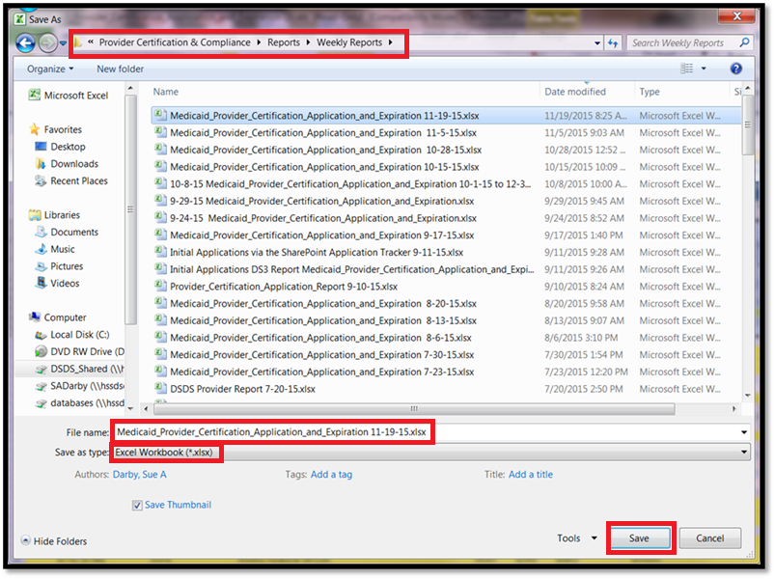)

* Save the report in [G:\Provider Certification & Compliance\Reports\Weekly Reports](about:blank) as Medicaid\_Provider\_Certification\_Application\_and\_Expiration <current date>.xlsx

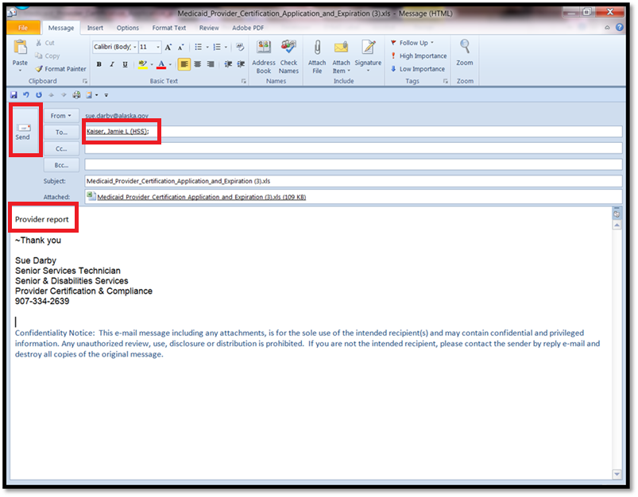

* **Email** a copy of the report to the **MAA II**





QuickSteps In Outlook - Tools

Friday, December 11, 2015

1:13 PM

The most efficient way to learn to setup a QuickStep is via the following YouTube

<https://www.youtube.com/watch?v=dmnjg6LRRaA>

Outlook Signatures - Tools

Tuesday, October 27, 2015

8:16 AM

Setting up a Signature or two in Outlook 2010 is simple with this YouTube.

<https://www.youtube.com/watch?v=DtvD4iidb4Y>

Quick Parts - Tools

Friday, October 23, 2015

2:11 PM

Word and Outlook have a tool called QuickParts that can make reusing text easy. To set it up follow this quick YouTube.  
<https://www.youtube.com/watch?v=ojGSeOQXhAY>

Screen Shots - Tools

Tuesday, December 08, 2015

9:22 AM

CTRL-Prt-Scn will screen shot the who screen both screens if you have two. To get just ONE screen use CTRL-Alt-Prt-Scrn. This makes creating new procedures with images easy.

It can sometimes be tricky to take screen shots of dialog boxes so there is also a Snipping tool build into Windows for those cases.

File Formats - Tools

Monday, November 30, 2015

2:02 PM

When information comes in via email it will come in as PDF or a doc or docx (Word), rtf, txt (standard word processing applications like Open Office or Libre Office) and even wps (Word Perfect Suite) most of the time but other formats have been known to pop up. Image files such as jpg, tif, gif and png are also common. Simply save to a folder on your desktop, select all and merge and convert to PDF. Once in a while files will come in that cannot be converted such as those for Photoshop or other unique software applications. If after googling the extension it is determined that there is no application that is compatible simply tell the provider to use a different format.

Adobe DC can merge and convert most file types and can even combine various file types into a PDF i.e. a doc, pdf and a jpg can be merged seamlessly. If after a file is in PDF format that it needs to be in Word for editing Adobe can convert, although imperfectly to Word but if the document is large then it is better than retyping. The software will do what is known as OCR or object character recognition to the file to find all the useful text. The conversion process will not harm the original files or even the pdf, it enhances the search ability of a pdf file.

Merging and Splitting Documents - Tools

Thursday, October 15, 2015

9:20 AM

**How to Merge or split documents**

* + There are two topics that are covered first, single attachments and multiple attachments sometimes in multiple emails.
  + For multiple attachments sent via email save them to a new folder on your desktop or other favorite temporary file spot. Multiple files are combined before date stamping to preserve page numbering.
  + Open single attachments directly by double clicking to open in Adobe DC no saving necessary.
  + For multiple attachments from one provider or source (can be multiple emails with multiple attachments from one person) save to a new folder (naming the folder doesn’t matter at this time it is deleted later.)
  + **Navigate** to the folder with all the files

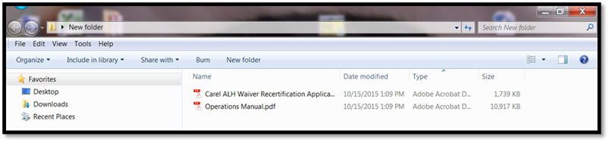

* + **Select** all the files

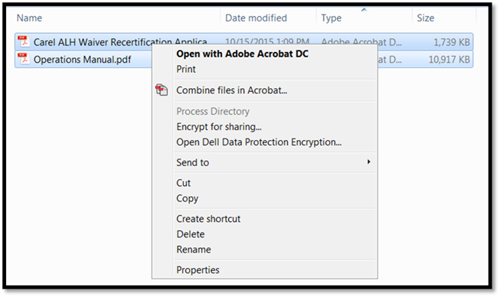

* + **Right click** and go to **Combine files in Adobe Acrobat**

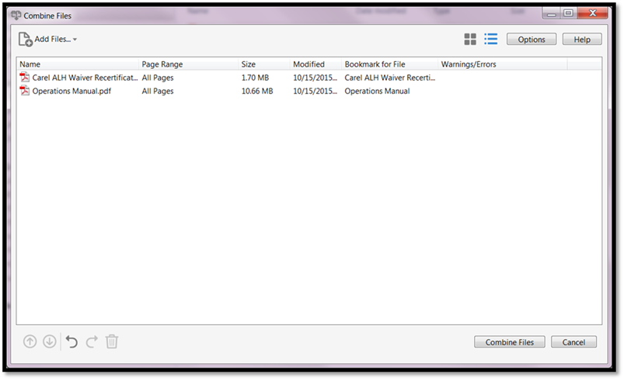

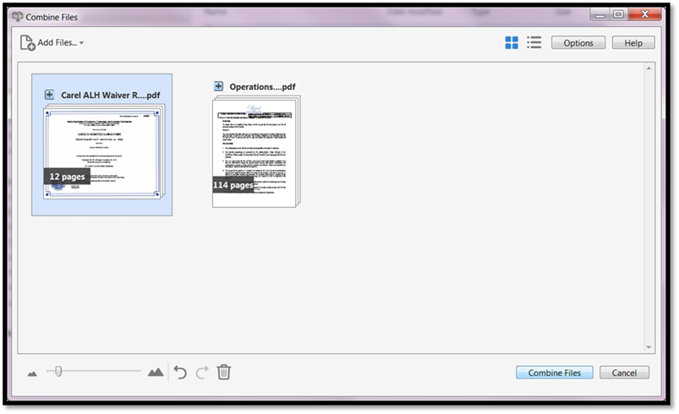

* + A dialog box will open and you can drag and drop the files into the order you’d like them merged.
  + **Merge** the files
  + The new “Binder file” will open

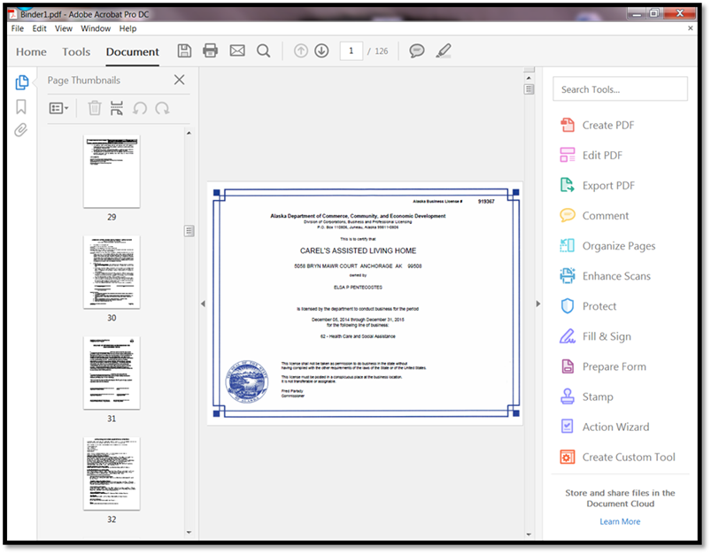

* + From here you can edit page order, add a date stamp or other header or footer or even save as a Word Document once more for additional editing